**High Level Use Case Diagrams**

**Task 2 – Use case**

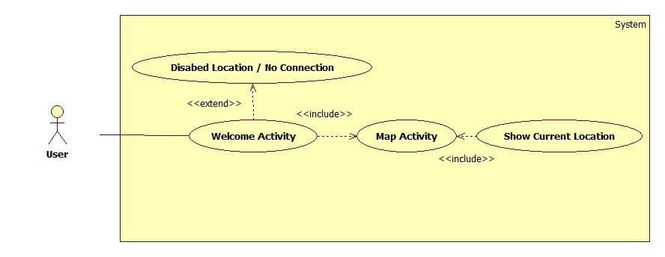



**Task 3 – Use case**

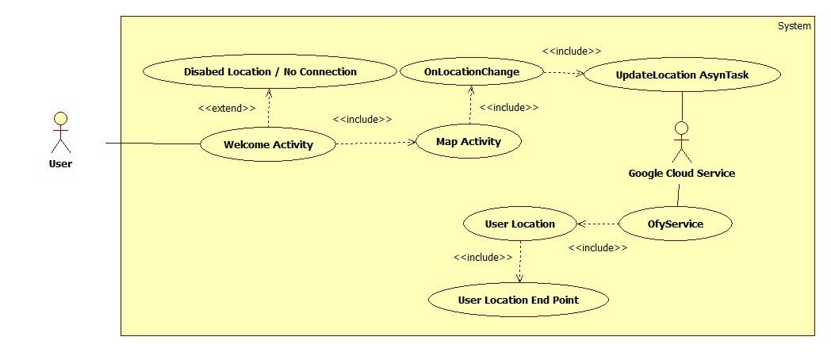

**Task 4 – Use case**

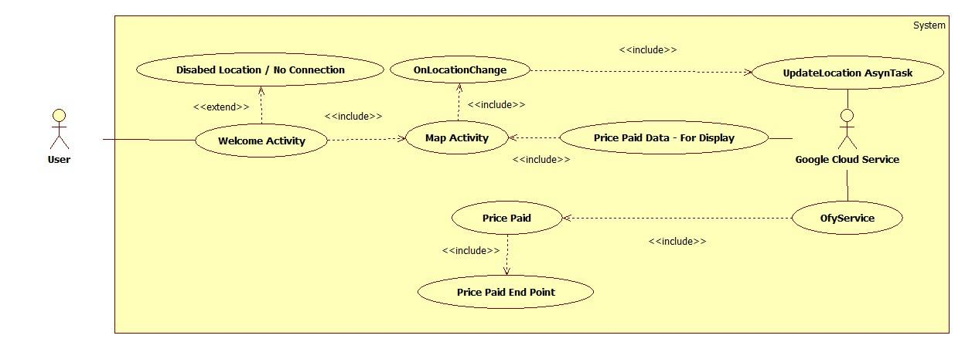

**Activity diagrams**

**Task 2 – Activity diagram**

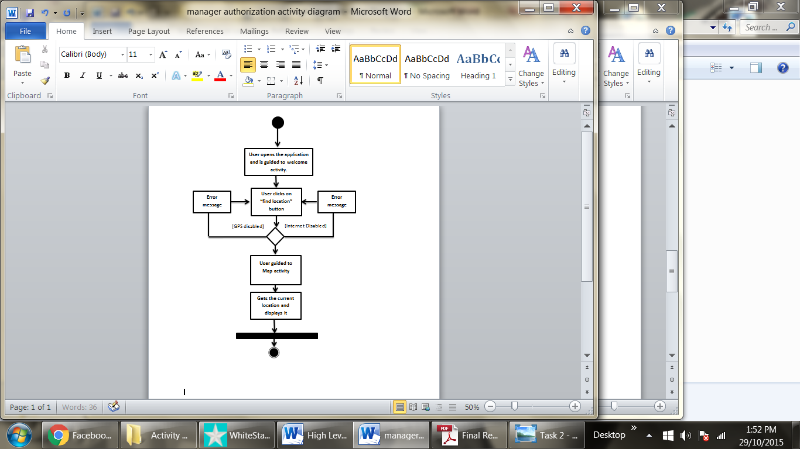



**Task 3- Activity diagram**

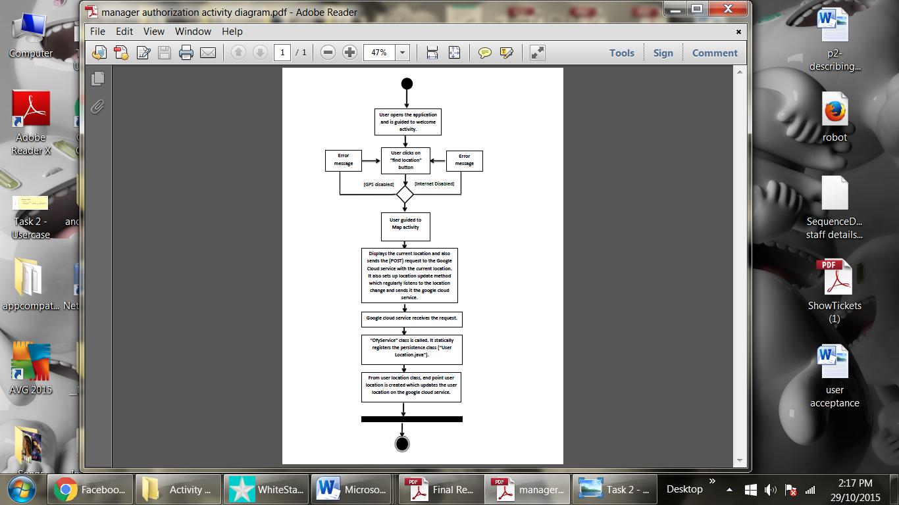



**Task 4- Activity diagram**

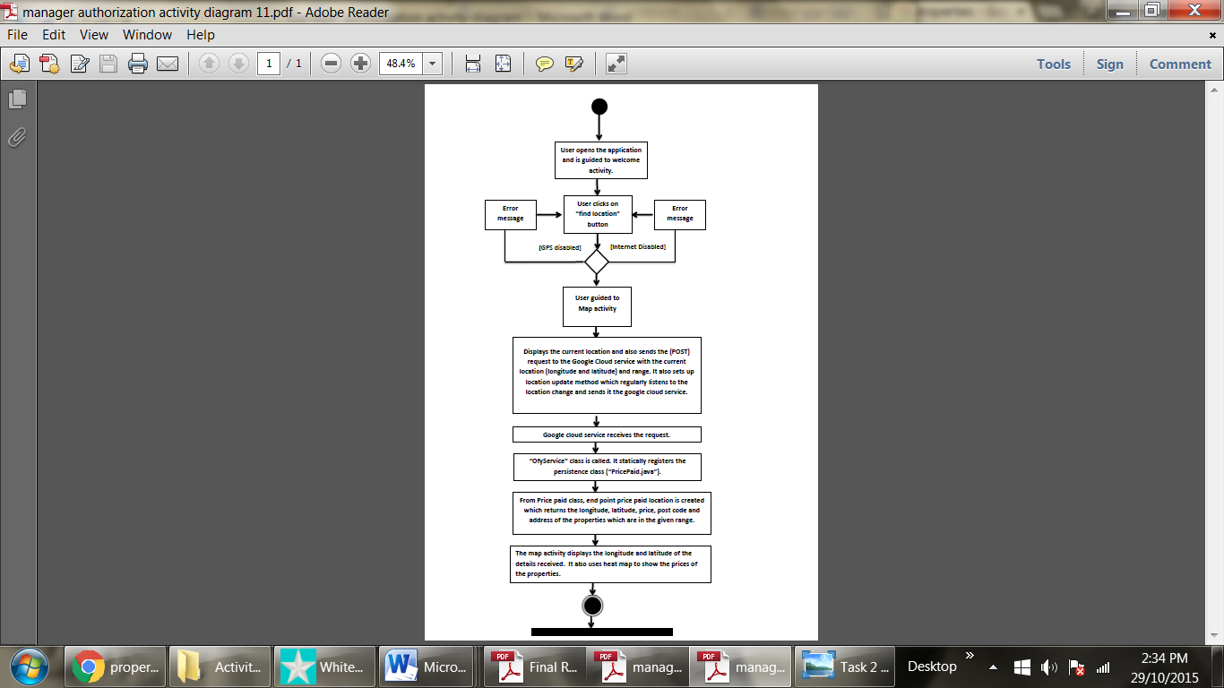



**Class diagrams**

**Task 2 – Class Diagram**

